User Information Form  Transnational Access Activity  Please fill in the requested information in the grey highlighted fields, which is demanded by the EU. All information will be treated confidentially.  Remember to acknowledge any support under EUPRIM-Net in all resulting publications with "Part of this work has been supported by EUPRIM-Net under the EU contract RII3-026155 of the 6th Framework Programme"  BioBank: | 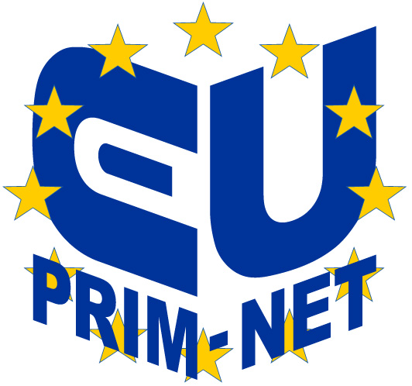  www.euprim-net.eu

Family Name: |  |  | Researcher Status:
 |  |  | Project Leader: Yes No
First Name: |  |  | New User: Yes No
Gender | F M |  | Scientific Background:
Birth year:
Nationality:
E-Mail:
Home Institution
Name:
Type:
Adress :
Country:
User Project
Title: max 255 characters
Acronym: |  | max. 20 characters
Project Leader:
Project Objectives: Summarise the objectives of the project in a few sentences. Max. 250 words.
Project Achievements: Describe the main achievements obtained and difficulties encountered during the project so far. Additionally, you can list project related publications here. Max. 250 words.
Main scientific field: |  |  | FP6 priority or specific discipline:

Each group leader of a user project supported under this EC Research Infrastructure contract is requested to complete the User Group Questionnaire of the European Commission. The questionnaire at http://cordis.europa.eu/infrastructures/questionnaire.htm must be submitted once by each user group as soon as the material samples have been obtained.

